# 

**Joshua 24:14**

**But if serving the Lord seems ____________to you, then _______ for yourselves this day whom you will serve, whether the gods your __________ served beyond the Euphrates, or the gods of the Amorites, in whose land you are living. But as for ___ and my ____________, we will serve the Lord.**

**Link Reminder**

After __________ another generation arose that knew ______ the Lord. Israel became _________. They repented and cried out for deliverance, and God sent them the _________.

Invasion and Conquest through the Judges

There were three different campaigns during the Invasion and Conquest of the land: The Central campaign, Southern campaign, and Northern campaign.

Northern

Fight the kings of the North led by Jabin king of Hazor.

Southern

Treaty with the Gibeonites and fight the kings of the South.

Central

Defeat of Jericho, Bethel, and Ai.

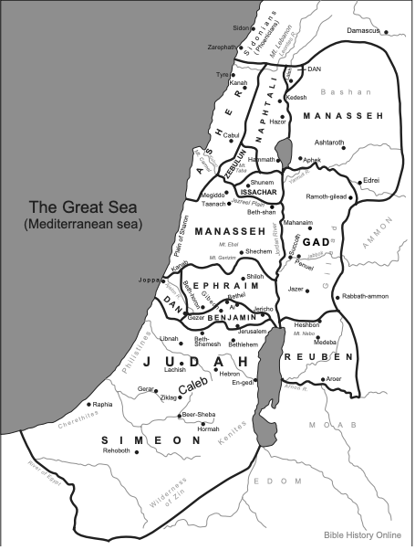

Answers: 1. Joseph, Ephraim & Manasseh his sons. 2. Levi

Bonus Questions:

Which tribe/child of Israel (Jacob) is missing? Who replaced him?

Which tribe did not receive land? What did they receive instead?

The Land is now divided up between the twelve tribes. Color the map using the key below.

Rueben- Red

Simeon- Orange

Levi- Yellow

Judah- Green

Dan- Dark Blue

Naphtali- Light Blue

Gad- Light green

Asher- Light Purple

Issachar- Pink

Zebulun- Brown

Benjamin- Grey

Ephraim- Dark Purple

Manasseh- Teal

Which book of the bible other than the Judges is in the time period of the Judges?

Hint: She’s a woman who’s in the lineage of Christ

Unscramble the Judges to the Order They Belong

Samson

Tola

Othniel

Deborah

Gideon

Shamgar

Jair

Jephthah

Abimelech

Elon

Eli

Abdon

Samuel

Ehud

Ibzan

________________________________________________________________________________________________________________________________________________________________________________________________________________________________________________________________________________________________________________________________________________________________________________________________________________________________________________________________________________________________

**Rebellion**

**Oppression**

**Repentance**

**Deliverance**

Judges

God’s people are in a downward spiral. They rebel against God and worship other idols which leads to God allowing them to be oppressed by other nations. They cry out and repent and God delivers them by sending a judge and there is rest in the land.

But the rest never lasts because it’s not long before they repeat the cycle again and again!