# 

uSal

____

Dvdai

_____

oSlonmo

_______

Which judge is the link between the period of the Judges and the period of the United Kingdom?

_________________

Unscramble to list the 3 Kings of the United Kingdom:

“Then all the _______ of Israel gathered together and came to_______ at Ramah; and they said to him, “Behold, you have grown ______ , and your _______ do not walk in your ways. Now appoint a _______ for us to judge us like all the nations.” But the thing was displeasing in the sight of Samuel when they said “Give us a _______ for us to judge us like all the nations.”

1 Samuel 8:4-5

United Kingdom through the Years of Silence

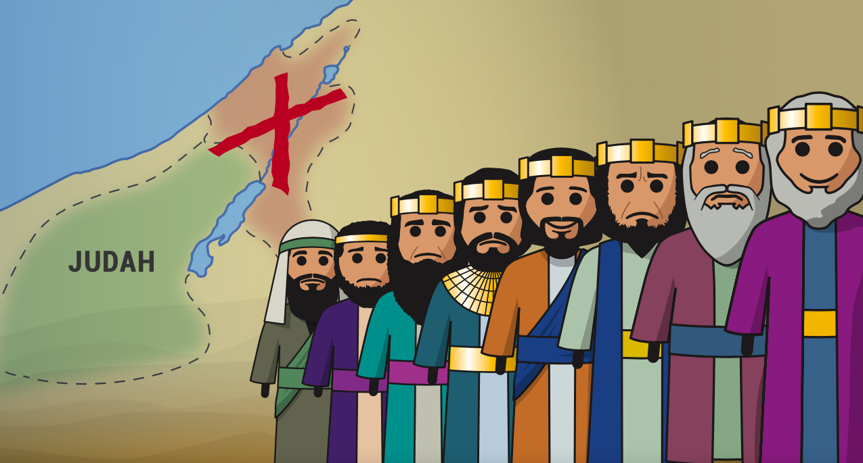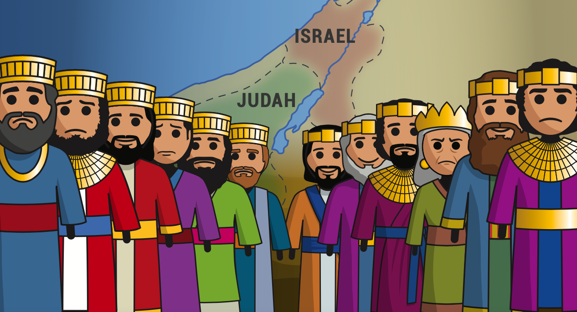

Judah Alone

Prophets:

* **Zephaniah**
* **Jeremiah**
* **Habbakkuk**
* **Nahum**

Kings:

* **Hezekiah**
* **Manasseh**
* **Josiah**

Divided Kingdom

**Why is Judah alone? What happened to the nation of Israel?**

_______________________________________

Prophets who prophesy during this time:

* **Obadiah**
* **Joel**
* **Amos**
* **Hosea**
* **Isaiah**
* **Micah**

The Kingdom is divided with Rehoboam in the south (Judah) and Jeroboam in the North (Israel).



This time period lasts 200 years until Israel (in the North) is taken away into captivity.

Captivity



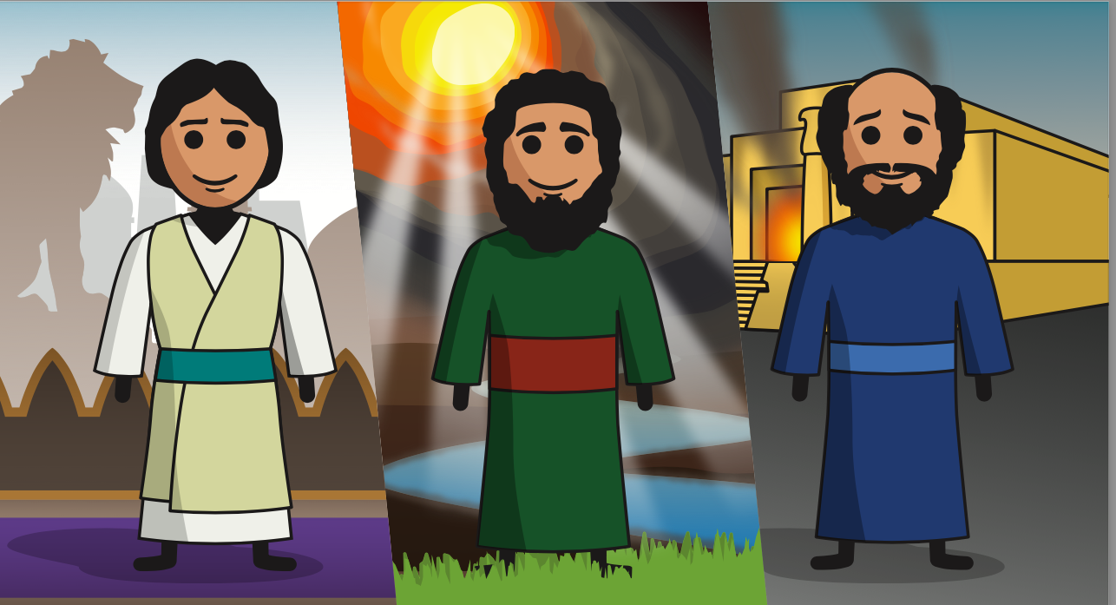

Ezekiel

Ezekiel 1:2 clues us in on the time period for the book of Ezekiel.

Which king is reigning in Ezekiel 1:2? _______________________

Babylon has taken Judah captive and now both the nation of Israel AND Judah are in Captivity.

Who was Ezekiel? (Ezekiel 1:3)

List some of the main events that happen during the book of Ezekiel:

1.___________________________

2.___________________________

3.___________________________

4.___________________________

Daniel

Daniel 1:1-2 clues us in to the time period Daniel falls into.

Which king is reigning in Daniel 1:1? _______________________

Babylon has taken Judah captive and now both the nation of Israel AND Judah are in Captivity.

Who was Daniel? (Daniel 1:4)

List some of the main events that happen during the book of Daniel:

1.___________________________

2.___________________________

3.___________________________

4.___________________________

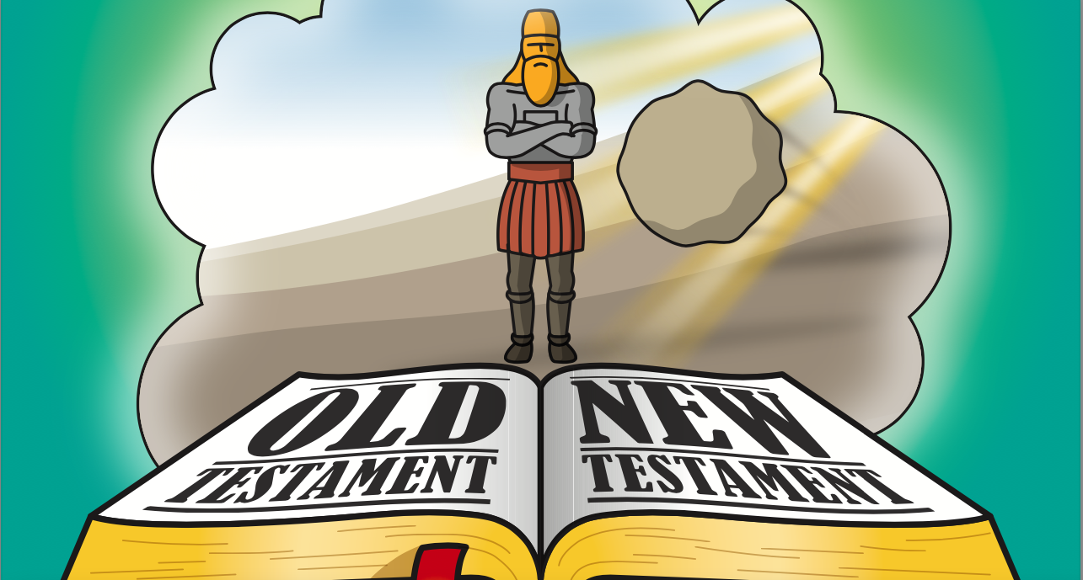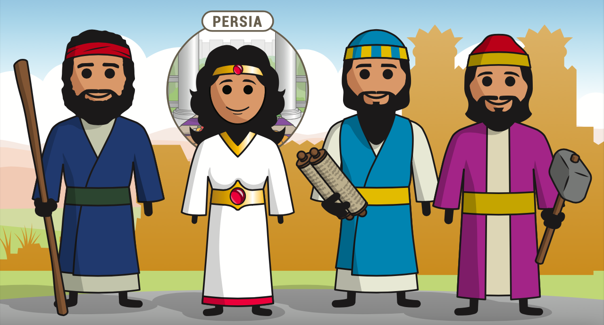

How many years of silence are there?

List 3 events that happen during the Years of Silence:

1.____________________________

2. ____________________________

3. ____________________________

Years of Silence

Who are some of the main people who are in the Return From Captivity?

(Hint: a woman who has a book in the Bible is one)

Zerubbabel (536 BC.) along with Jeshua the high priest, with around 50,000 Jews. Haggai and Zechariah prophets. Jews started building the temple, got stopped after one year. Enemies waited until Cyrus was dead, then wrote to Cambyses about Jerusalem. He ordered that the building be stopped. Prophets Haggai and Zechariah stirred the people to build the temple (520-516 BC.) Esther ﬁts in between Ezra chapters 6 and 7. About 485 BC, Ezra leads a return (458 BC). Concentrates on purifying the worship. Then Nehemiah comes to build the walls of Jerusalem (445 BC.) Malachi the last prophet of the Old Testament (432 BC).

Return From Captivity