# 

Wandering in the Wilderness

**Miriam dies in Numbers 20 who were her brothers?**

**____________________________**

**What happened to Aaron’s rod that showed he was chosen by God?**

**____________________________**

Which 3 men are specifically mentioned in Numbers 16 as rebelling against Moses and Aaron? Unscramble the words.

baAmri

______

tDanah

______

oahKr

_____

## 

Numbers 14:1-4. That night all the members of the community raised their voices and wept aloud. **2**All the Israelites **grumbled**against _________ and __________, and the whole assembly said to them, “If only we had _____________________________! Or in this wilderness! **3**Why is the Lord bringing us to this land only to let us fall by the sword? Our wives and children will be taken as plunder. Wouldn’t it be **better** for us to go back to Egypt?” **4**And they said to each other, “______________________________________________________.”

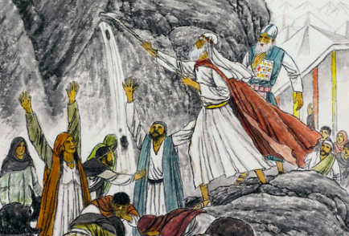

Numbers 20

The people complain about water again and God answers. Moses and Aaron sin and can no longer enter the promised land.

God’s command to Moses: (v. 7 & 8)

The Lord said to Moses,“Take the _________ , and you and your brother __________ gather the assembly together. ____________ to that rock before their eyes and it will pour out its ______________. You will bring water out of the rock for the community so they and their livestock can drink.”

Moses’s Actions: (v. 10 & 11)

He and _______ gathered the assembly together in front of the rock and Moses said to them, “Listen, you rebels, must ______ bring you water out of this rock?” **11**Then Moses raised his arm and ___________ the rock ________ with his staff. __________ gushed out, and the community and their livestock drank.

God’s command:

____________ the rock.

Moses’s Actions:

He ____________ the rock.

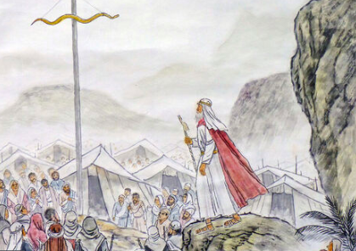

**What were the Israelites to look at to be saved from their serpent bites?**

**__________________**

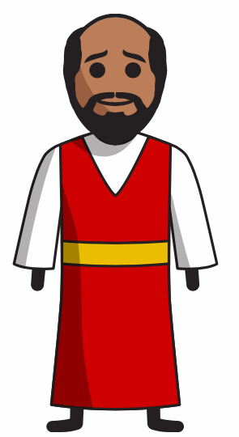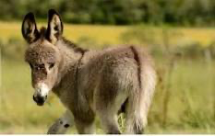

**Numbers 22- Balaam and the donkey**

**“God said to _____________, “Do NOT go with them. You must not put a ___________ on those people, because they are ___________.”**

**What animal talked to Balaam to stop him from going where the angel was? (v.22-23)**

**What happened every time Balaam tried to curse the Israelites?**

Memory Refresh!

Which time period comes BEFORE the Wandering in the Wilderness?

Which time period comes AFTER the Wandering in the Wilderness?

What chapter does Moses die in Numbers?

Do we know where Moses is buried today? Why or why not?

What books/chapters cover the period of the Wandering in the Wilderness?